**CSE421**

**Lab Project Report**



**ISP company: “Fastest”**

**Section - 07 Group: 57**

**Group Members**

NAIMA AHMED NUP 19101430

MD. RAISUL KABIR NEWS 19101058

MUHAMMED NUFAYEL 19301341

**VLSM/Network Address Table**

**Parent Network Address: 192.168.0.0/24**

|  |  |  |  |  |  |  |
| --- | --- | --- | --- | --- | --- | --- |
| **Node** | **4*Current**  **Host** | **Hosts needed** | **Hosts  given** | **Host Bits** | **Network Address** | **Prefix mask** |
| **DHAKA** | 4*512 | 2048 | 4094 | 12 | 192.168.0.0 | /20 |
| **MUNSHIGANJ** | 4*256 | 1024 | 2046 | 11 | 192.168.16.0 | /21 |
| **TANGAIL** | 4*64 | 256 | 510 | 9 | 192.168.24.0 | /23 |
| **GAZIPUR** | 4*32 | 128 | 254 | 8 | 192.168.26.0 | /24 |
| **MANIKGANJ** | 4*16 | 64 | 126 | 7 | 192.168.27.0 | /25 |
| **NARSHINDI** | 4*8 | 32 | 62 | 6 | 192.168.27.128 | /26 |
| **WAN1** |  | 2 | 2 | 2 | 192.168.27.192 | /30 |
| **WAN2** |  | 2 | 2 | 2 | 192.168.27.196 | /30 |
| **WAN3** |  | 2 | 2 | 2 | 192.168.27.200 | /30 |
| **WAN4** |  | 2 | 2 | 2 | 192.168.27.204 | /30 |
| **WAN5** |  | 2 | 2 | 2 | 192.168.27.208 | /30 |
| **WAN6** |  | 2 | 2 | 2 | 192.168.27.212 | /30 |
| **WAN7** |  | 2 | 2 | 2 | 192.168.27.216 | /30 |

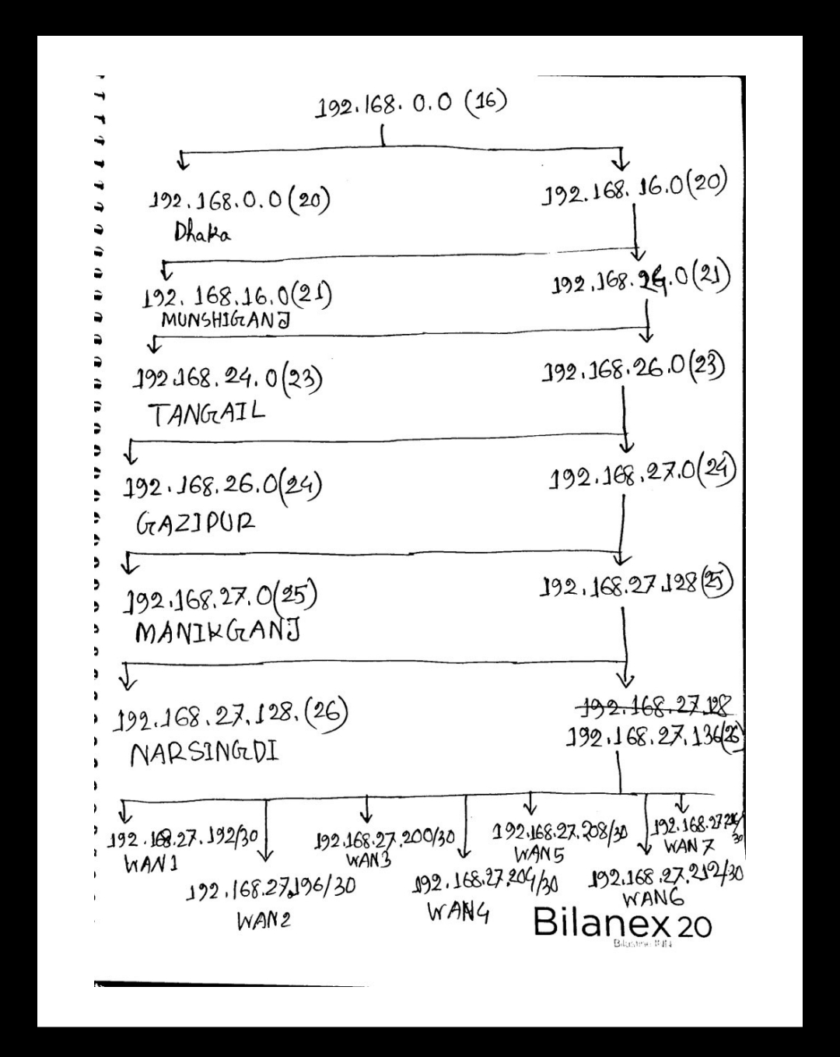

**IP Address Table**

|  |  |  |  |  |
| --- | --- | --- | --- | --- |
| **Device** | **Interface** | **IP Address** | **Subnet Mask** | **Default Gateway** |
| PC0 | NIC | 192.168.26.3 | 255.255.255.0 | 192.168.26.1 |
| PC1 | 192.168.26.4 | 255.255.255.0 | 192.168.26.1 |
| PC2 | 192.168.24.2 | 255.255.254.0 | 192.168.24.1 |
| PC3 | 192.168.24.3 | 255.255.254.0 | 192.168.24.1 |
| PC4 | DHCP Assigned | DHCP Assigned | DHCP Assigned |
| PC5 | DHCP Assigned | DHCP Assigned | DHCP Assigned |
| PC6 | 192.168.16.2 | 255.255.248.0 | 192.168.16.1 |
| PC7 | 192.168.16.3 | 255.255.248.0 | 192.168.16.1 |
| PC8 | 192.168.27.2 | 255.255.255.128 | 192.168.27.1 |
| PC9 | 192.168.27.3 | 255.255.255.128 | 192.168.27.1 |
| PC10 | 192.168.27.130 | 255.255.255.192 | 192.168.27.129 |
| PC11 | 192.168.27.131 | 255.255.255.192 | 192.168.27.129 |
| DHCP Server (Distributor) | 192.168.0.2 | 255.255.240.0 | 192.168.0.1 |
| Web Server (Bari) | 192.168.26.2 | 255.255.255.0 | 192.168.26.1 |

|  |  |  |  |  |
| --- | --- | --- | --- | --- |
| **Device** | **Interface** | **IP Address** | **Subnet Mask** | **Default Gateway** |
| DHAKA | Fa0/0 | 192.168.0.1 | 255.255.240.0 | NA |
| Se2/0 | 192.168.27.194 | 255.255.255.252 |
|  | Se3/0 | 192.168.27.197 | 255.255.255.252 |
| MUNSHIGANJ | Fa0/0 | 192.168.16.1 | 255.255.248.0 |
| Se2/0 | 192.168.27.198 | 255.255.255.252 |
| Se3/0 | 192.168.27.201 | 255.255.255.252 |
| Se6/0 | 192.168.27.209 | 255.255.255.252 |
| TANGAIL | Fa0/0 | 192.168.24.1 | 255.255.254.0 |
| Se2/0 | 192.168.27.217 | 255.255.255.252 |
| Se3/0 | 192.168.27.193 | 255.255.255.252 |
| GAZIPUR | Fa0/0 | 192.168.26.1 | 255.255.255.0 |
| Se2/0 | 192.168.27.218 | 255.255.255.252 |
| Se3/0 | 192.168.27.213 | 255.255.255.252 |
|
| MANIKGANJ | Fa0/0 | 192.168.27.1 | 255.255.255.128 |
| Se2/0 | 192.168.27.202 | 255.255.255.252 |
| Se3/0 | 192.168.27.205 | 255.255.255.252 |
|
| NARSHINGDHI | Fa0/0 | 192.168.27.129 | 255.255.255.192 |
| Se2/0 | 192.168.27.206 | 255.255.255.252 |
|  | Se3/0 | 192.168.27.214 | 255.255.255.252 |  |
|  | Se6/0 | 192.168.27.210 | 255.255.255.252 |  |

**Router Configuration Commands**

**DHAKA**

**Router Configuration**

enable

configure terminal

hostname DHAKA

interface FastEthernet0/0

ip address 192.168.0.1 255.255.240.0

no shut

interface Serial2/0

ip address 192.168.27.194 255.255.255.252

no shut

interface Serial3/0

ip address 192.168.27.197 255.255.255.252

no shut

exit

**Dynamic Routing And Redistribute**

router rip

version 2

redistribute static

redistribute connected

passive-interface FastEthernet0/0

network 192.168.0.0 **(Dhaka)**

network 192.168.27.192 **(WAN 1)**

network 192.168.27.196 **(WAN 2)**

no auto-summary

end

copy run start

**Static Routing**

ip route 192.168.16.0 255.255.248.0 192.168.27.198 **(Munshiganj Lan)**

ip route 192.168.27.200 255.255.255.252 192.168.27.198 **(WAN 3)**

ip route 192.168.27.0 255.255.255.128 192.168.27.198 **(Manikganj Lan)**

ip route 192.168.27.204 255.255.255.252 192.168.27.198 **(WAN 4)**

ip route 192.168.27.128 255.255.255.192 192.168.27.198 **(Narshindi Lan)**

**Floating Static Routing**

ip route 192.168.27.208 255.255.255.252 192.168.27.198 **5 (WAN 5)**

**MUNSHIGANJ**

**Router Configuration**

enable

configure terminal

hostname DHAKA

interface FastEthernet0/0

ip address 192.168.16.1 255.255.248.0

no shut

interface Serial2/0

ip address 192.168.27.198 255.255.255.252

no shut

interface Serial3/0

ip address 192.168.27.201 255.255.255.252

no shut

interface Serial6/0

ip address 192.168.27.209 255.255.255.252

no shut

exit

**Redistribute Command**

router rip

version 2

redistribute static

redistribute connected

**Static Routing**

ip route 192.168.27.192 255.255.255.252 192.168.27.197 **(WAN 1)**

ip route 192.168.27.204 255.255.255.252 192.168.27.202 **(WAN 4)**

ip route 192.168.27.212 255.255.255.252 192.168.27.197 **(WAN 6)**

ip route 192.168.27.216 255.255.255.252 192.168.27.197 **(WAN 7)**

ip route 192.168.27.0 255.255.255.128 192.168.27.202 **(Manikganj Lan)**

ip route 192.168.27.128 255.255.255.192 192.168.27.202 **(Narsingdi Lan)**

ip route 192.168.0.0 255.255.240.0 192.168.27.197 **(Dhaka Lan)**

ip route 192.168.24.0 255.255.254.0 192.168.27.197 **(Tangail Lan)**

ip route 192.168.26.0 255.255.255.0 192.168.27.197 **(Gazipur Lan)**

**Floating Static Routing**

ip route 192.168.27.128 255.255.255.192 192.168.27.210 **5** **(Narsingdi Lan)**

**TANGAIL**

**Router Configuration**

enable

configure terminal

hostname TANGAIL

interface FastEthernet0/0

ip address 192.168.24.1 255.255.254.0

no shut

interface Serial2/0

ip address 192.168.27.217 255.255.255.252

no shut

interface Serial3/0

ip address 192.168.27.193 255.255.255.252

no shut

exit

**Dynamic Routing**

router rip

version 2

passive-interface FastEthernet0/0

network 192.168.24.0 **(Tangail)**

network 192.168.27.216 **(WAN 7)**

network 192.168.27.192 **(WAN 1)**

no auto-summary

end

copy run start

**GAZIPUR**

**Router Configuration**

enable

configure terminal

hostname GAZIPUR

interface FastEthernet0/0

ip address 192.168.26.1 255.255.255.0

no shut

interface Serial2/0

ip address 192.168.27.218 255.255.255.252

no shut

interface Serial3/0

ip address 192.168.27.213 255.255.255.252

no shut

exit

**Dynamic Routing**

router rip

version 2

passive-interface FastEthernet0/0

network 192.168.26.0 **(Gazipur)**

network 192.168.27.216 **(WAN 7)**

network 192.168.27.212 **(WAN 6)**

no auto-summary

end

copy run start

**Floating Static Routing**

ip route 192.168.27.128 255.255.255.192 192.168.27.214 **130 (Narsingdi Lan)**

**MANIKGANJ**

**Router Configuration**

enable

configure terminal

hostname MANIKGANJ

interface FastEthernet0/0

ip address 192.168.27.1 255.255.255.128

no shut

interface Serial2/0

ip address 192.168.27.202 255.255.255.252

no shut

interface Serial3/0

ip address 192.168.27.205 255.255.255.252

no shut

Exit

**Static Route**

ip route 192.168.27.192 255.255.255.252 192.168.27.201 **(WAN 1)**

ip route 192.168.27.196 255.255.255.252 192.168.27.201 **(WAN 2)**

ip route 192.168.27.208 255.255.255.252 192.168.27.201 **(WAN 5)**

ip route 192.168.27.212 255.255.255.252 192.168.27.201 **(WAN 6)**

ip route 192.168.27.216 255.255.255.252 192.168.27.201 **(WAN 7)**

ip route 192.168.27.128 255.255.255.192 192.168.27.206 **(Narsingdi Lan)**

ip route 192.168.16.0 255.255.248.0 192.168.27.201 **(Munshiganj Lan)**

ip route 192.168.0.0 255.255.240.0 192.168.27.201 **(Dhaka Lan)**

ip route 192.168.24.0 255.255.254.0 192.168.27.201 **(Tangail Lan)**

ip route 192.168.26.0 255.255.255.0 192.168.27.201 **(Gazipur Lan)**

**NARSINGDI**

**Router Configuration**

enable

configure terminal

hostname NARSINGDI

interface FastEthernet0/0

ip address 192.168.27.129 255.255.255.192

no shut

interface Serial2/0

ip address 192.168.27.206 255.255.255.252

no shut

interface Serial3/0

ip address 192.168.27.214 255.255.255.252

no shut

interface Serial6/0

ip address 192.168.27.210 255.255.255.252

no shut

Exit

**Static Routing**

ip route 192.168.27.192 255.255.255.252 192.168.27.205 **(WAN 1)**

ip route 192.168.27.196 255.255.255.252 192.168.27.205 **(WAN 2)**

ip route 192.168.27.200 255.255.255.252 192.168.27.205 **(WAN 3)**

ip route 192.168.27.216 255.255.255.252 192.168.27.205 **(WAN 7)**

ip route 192.168.27.0 255.255.255.128 192.168.27.205 **(Manikganj Lan)**

ip route 192.168.16.0 255.255.248.0 192.168.27.205 **(Munshiganj Lan)**

ip route 192.168.0.0 255.255.240.0 192.168.27.205 **(Dhaka Lan)**

ip route 192.168.24.0 255.255.254.0 192.168.27.205 **(Tangail Lan)**

ip route 192.168.26.0 255.255.255.0 192.168.27.205 **(Gazipur Lan)**

**Floating Static Routing**

ip route 192.168.16.0 255.255.248.0 192.168.27.209 **130** **(Munshiganj Lan)**

ip route 192.168.27.196 255.255.255.252 192.168.27.209 **130 (WAN 2)**

ip route 192.168.0.0 255.255.240.0 192.168.27.209 **130**  **(Dhaka Lan)**

ip route 192.168.27.192 255.255.255.252 192.168.27.209 **130 (WAN 1)**

ip route 192.168.24.0 255.255.254.0 192.168.27.209 **130 (Tangail Lan)**

ip route 192.168.27.216 255.255.255.252 192.168.27.209 **130 (WAN 7)**

ip route 192.168.26.0 255.255.255.0 192.168.27.209 **130 (Gazipur Lan)**

ip route 192.168.26.0 255.255.255.0 192.168.27.213 **122 (Gazipur Lan)**

**ASSUMPTIONS**

1. Tangail and Gazipur have to communicate without human intervention. We configured this two network dynamically as in dynamic routing human don’t need to access each router and configure static rule. All the router information will be dynamically configured.

2. We statically configured Munshiganj, Manikganj, and Narshindhi as the connection between them should be 100% secure.

3. Dhaka is working as a connector between these two groups and we configured it as dynamically redistributed.

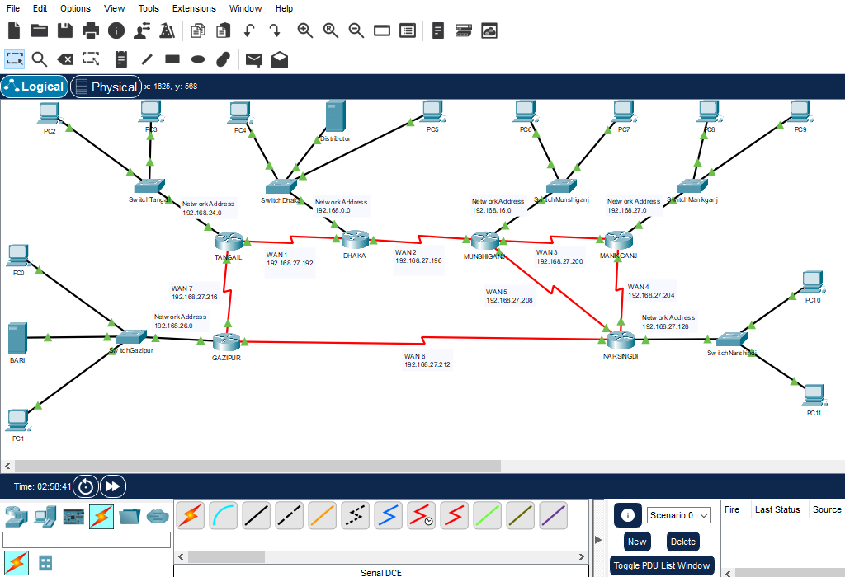

**Some Rough Notes:**

